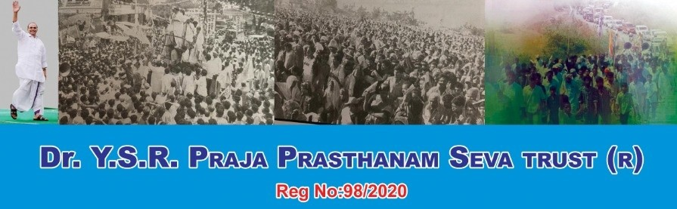
PROFILE
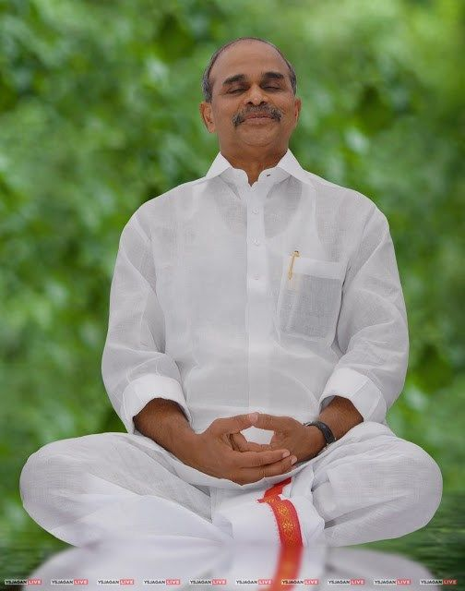

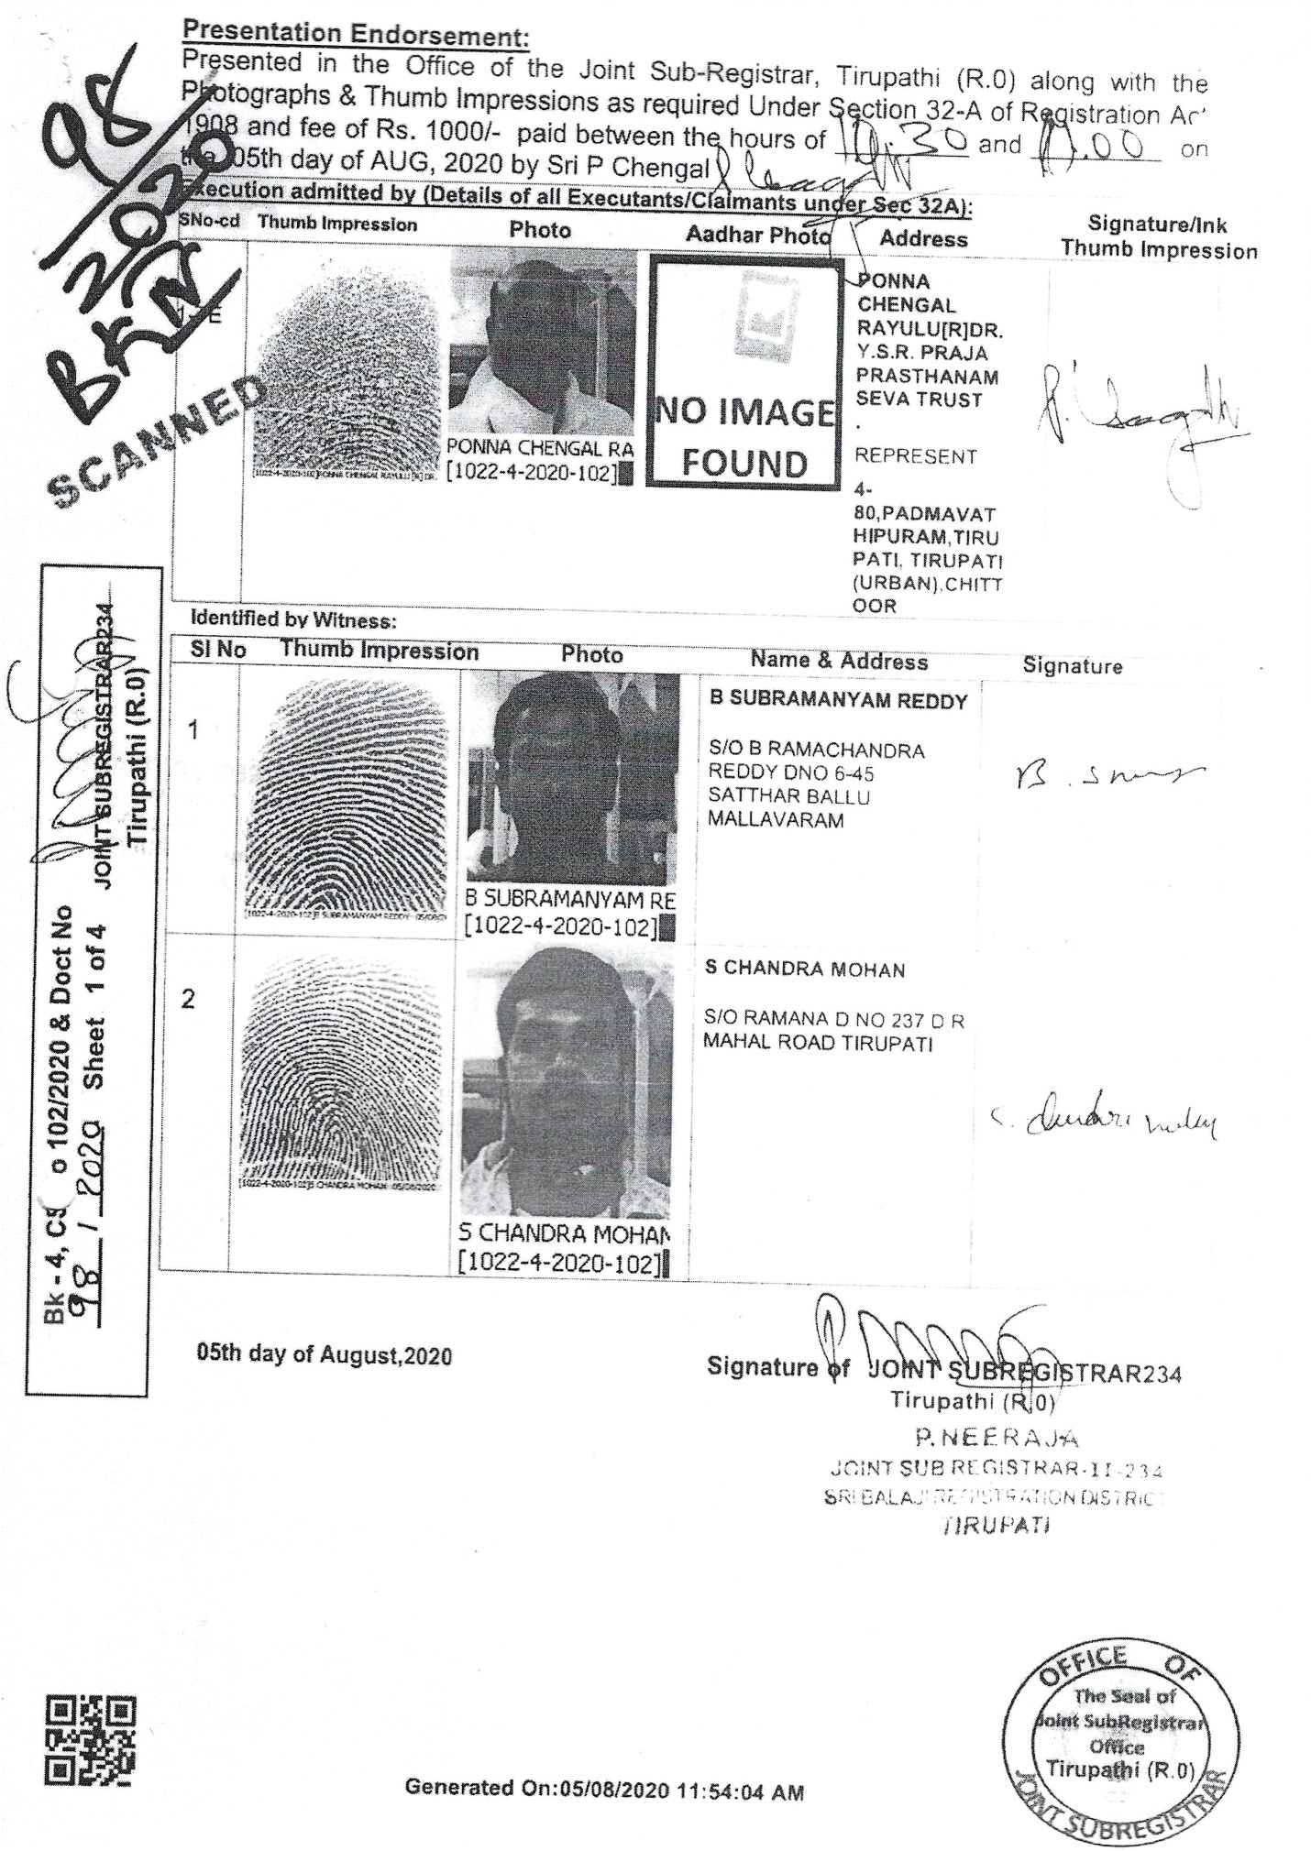
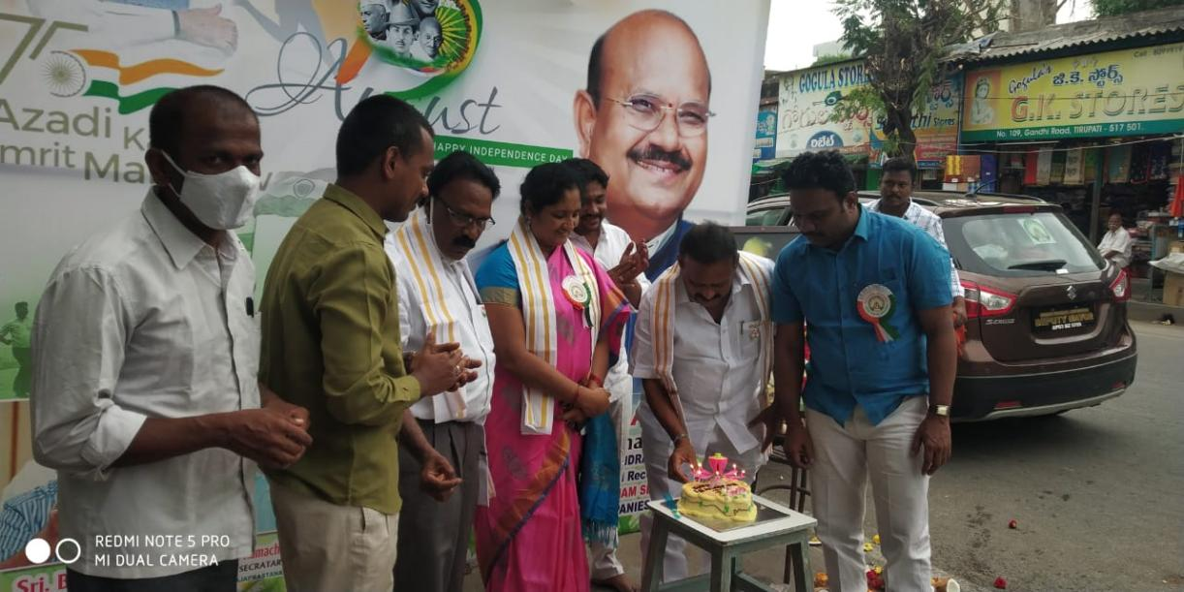
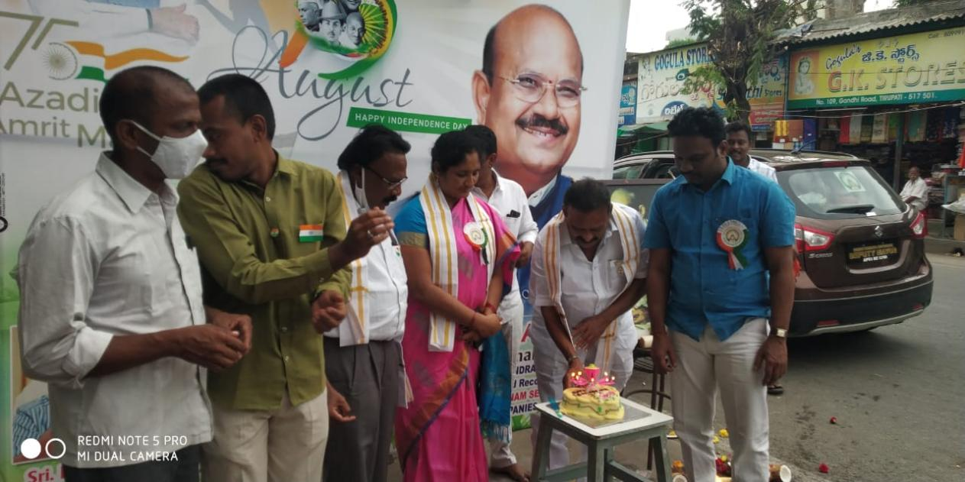
On the eve of the 75th Independence Day, Tirupati – based Dr.YSR Praja Prasthanam Seva Trust (R) and Kasturba Gandhi Kendra Trust (R) both NGOs, organised a programme by cutting a cake on 15.07.2021. They also distributed sweets and chocolates to the poor at a programme presided over by Chairman of the Trust Dr.P.C Rayulu.
Chief Guest Mudra Narayan, Deputy Mayor R.Sridevi, Vice chairman Bhuman and Secretary Ramachandara Reddy were present. Talking to the media, Chairman the Trust, paid rich tributes to the freedom fighters on the occasion. He said the Trust has been rendering service to the poor on various occasions.
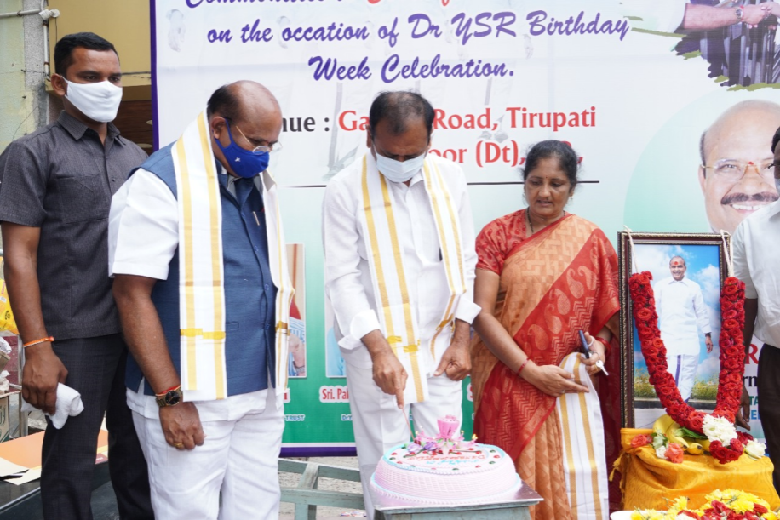
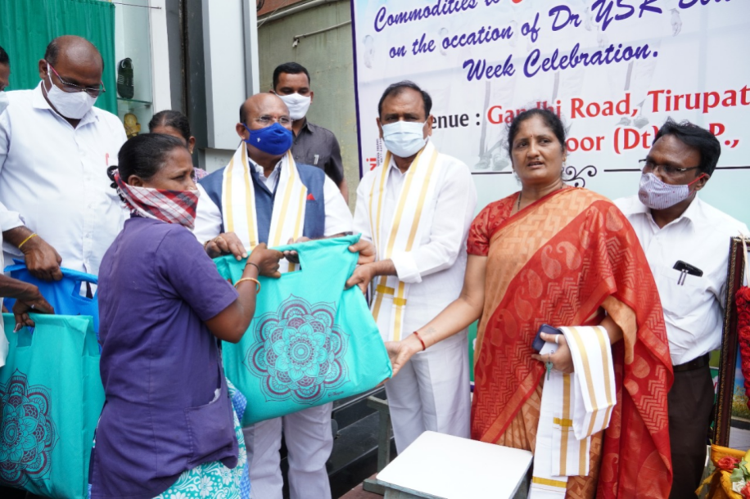
Rich tributes to Dr. Y.S.R
DR. YSR PRAJA PRASTHANAM SEVA TRUST has today organized Dr YSR JAYANTHI 13.07.2021 at Trust office, Gandhi Road here.
Tirupati MLA Mr. Bhumana Karunakar Reddy who attend the function has paid rich tributes to Dr YSR and Garland his photo on this occasion. He has distributed essential Commodities to 140 No’s to COVID-19 SECOND WAVE FRONT LINE sanitary workers of Tirupati municipal. corporation and Padmavathi Puram panchayat. Speaking on this occasion he appreciated the services of trust for providing essential commodities to needy persons.
Dr. PC RAYULU Chairman of the Trust who spoke on this occasion said that Dr.YSR was role model for the service rendered during his stint as a Chief Minister and said that his son Sri YS JAGANMOHAN REDDY like his father also took the same line and doing service to the people of ANDHRAPRADESH with his welfare schemes.
Mr. BHUMAN SUBRAMANYAM REDDY, VICE CHAIRMAN, Mr. PALAVALI RAMACHANDRA REDDY SECRETARY, RUDRARAJU SREEDEVI DIRECTER, G.SUBRAMANYAM REDDY, BANDI MADHUSUDHANA REDDY AND OTHERS PARTICIPATED ON THIS OCCASSION.

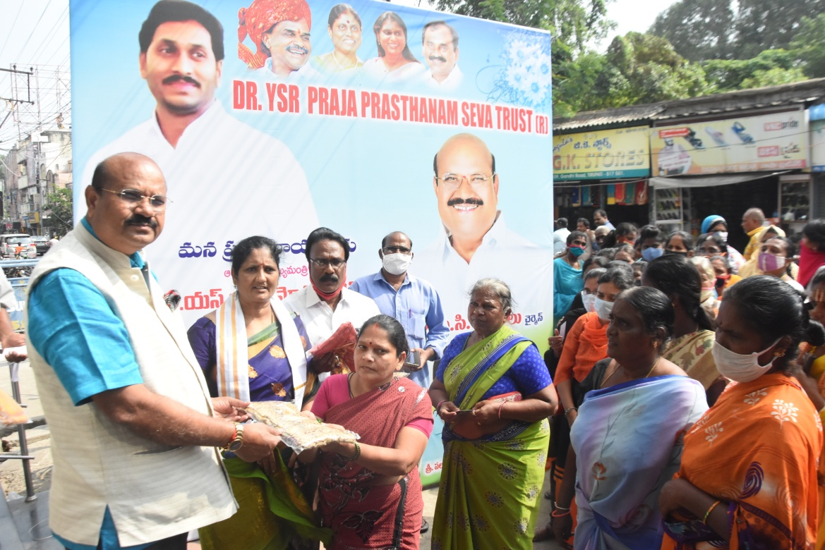
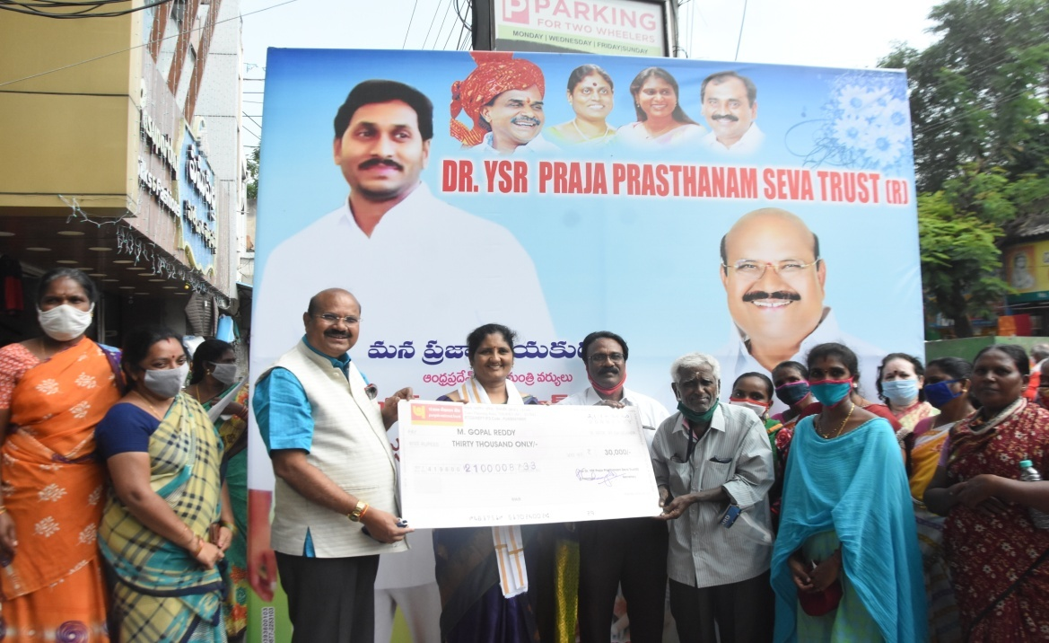
Dr.P.C.Rayulu, Chairman of Dr.YSR PRAJA PRASTHANAM SEVA TRUST has cut the cake and conducted on 21.12.2020 free distribution of clothes to the poor people at Gandhi Road, Tirupati on the occasion of Birth Day of Chief Minister of AP Sri Y S Jagan Mohan Reddy Garu. Sri Y S Jagan Mohan Reddy has implemented number of welfare schemes to the uplift of poor and needy people especially women. He wished and encouraged the poor people who work hard to move forward. The trust has done number of welfare programmes to the poor people of Tirupati and surrounding areas. The Trust has sponsored Rs. 30,000/- to the Rayalaseema and Andhra working journalist Union, State President, Sri Mabbu. Gopal Reddy. A chief guest Sri Bhumana Subramanyam Reddy Garu told that the AP CM implemented important schemes like education and health etc., those are very essential to the poor people.
Mr.P.Ramachandra Reddy Garu Manager Sricity, Trust Director, Smt.Rudraraju Sreedevi and Bandi.Madhusudhana Reddy participated on this occasion.
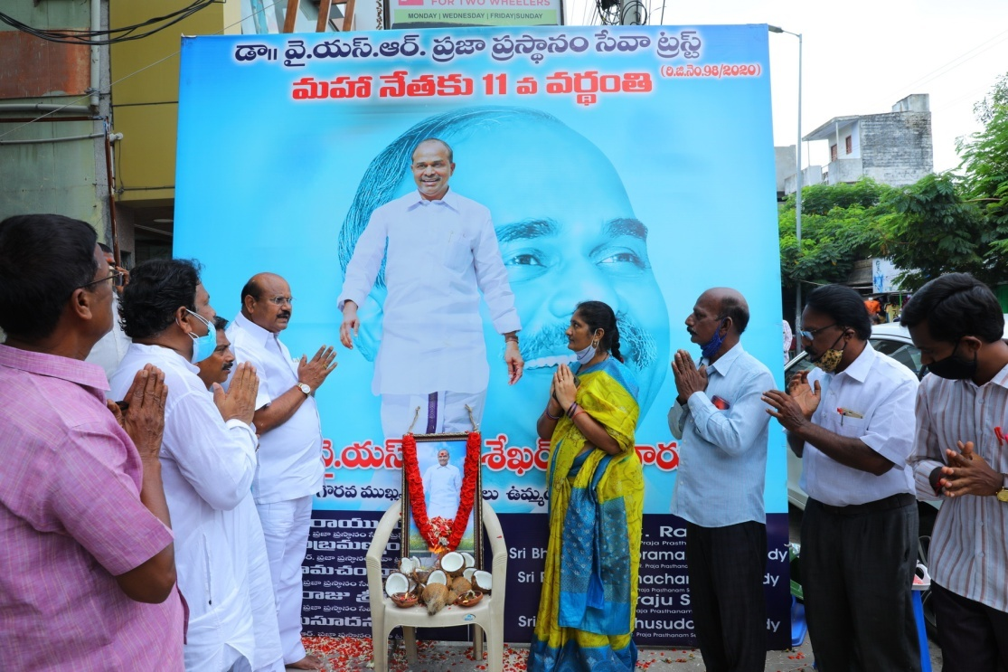
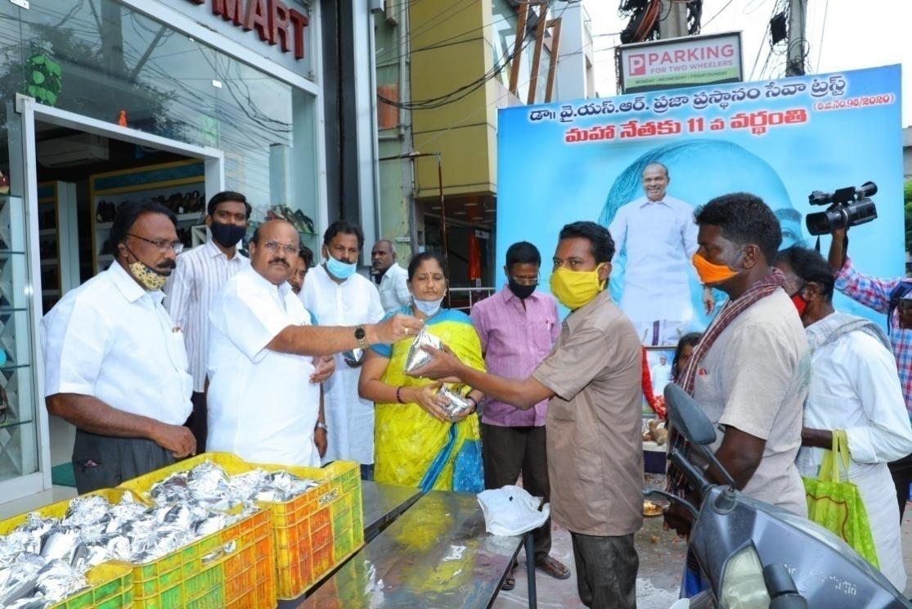
Dr.Y.S.Rajasekhar Reddy’s 11th death Anniversary was being organised by Dr.Y.S.R Praja Prasthanam Seva Trust (R) in Gandhi Road, Tirupati. On 02.09.2020 this occasion, Chairman of the Trust Dr.P.C Rayulu paid a great Tribute to Dr.Y.S.R and said that he was a great and dynamic leader. Under his leadership united Andhrapradesh has developed in many sectors and he has introduced several welfare schemes to the Public.
His successor, Shri Y.S Jaganmohan Reddy also following the steps of his father in public Domain.
On this occasion, Dr.Y.S.R Praja Prasthanam Seva Trust (R), Secretary, P.Ramachandra Reddy, Director Rudramaraju Sreedevi, Co-ordinator Bandi Madhusudhan Reddy, S.Shabuddin and others participated.
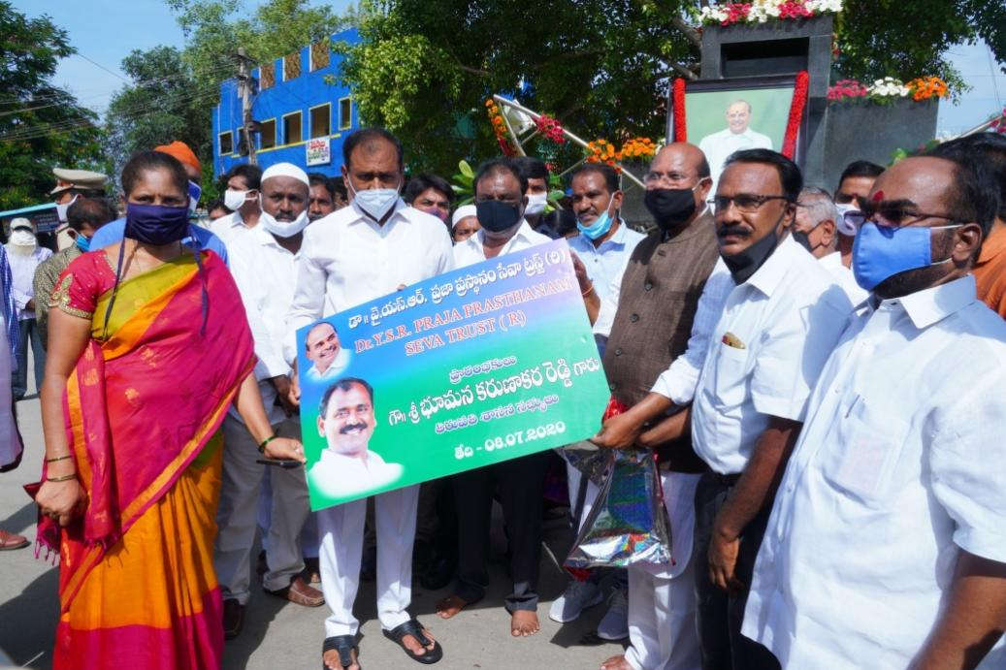
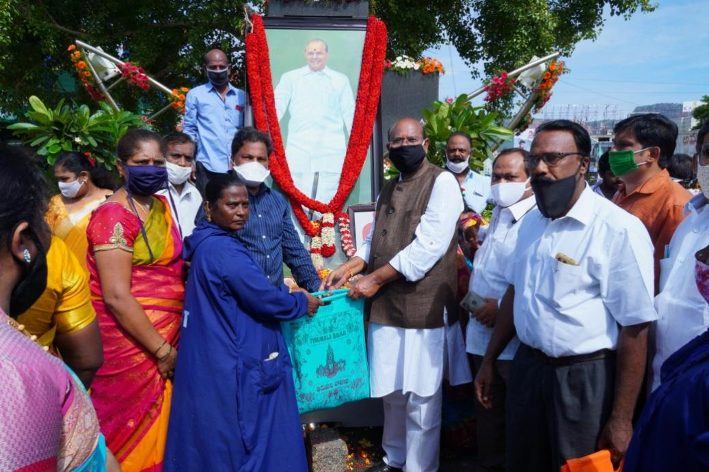
Mr. Bhumana Karunakara Reddy, MLA Tirupati has today launched Dr. YSR Praja Prasthanam Seva Trust on 08.07.2020 the occasion of his 71st Jayanthi celebrations of Late Dr. Y.S. Rajasekhar Reddy at TUDA office circle. Speaking on the occasion to the Media, Mr. Karunakar Reddy has paid rich tributes to his mentor and remembered his services to the people of united Andhra Pradesh. He said that he was proud to say that his son and incumbent chief minister Mr. Jagan Mohan Reddy was two steps ahead of his father in extending services to the state as well as people of Andhra Pradesh.

Dr. P.C. Rayulu, Chairman of Seva trust said that it was great opportunity for us to service deserving people on the banner of Dr. YSR PP Seva trust.

Earlier Mr. Karunakar Reddy has distributed to the essential commodities kit (5kg rice, 1ltr oil 1kg dall 1kg each of mirchi powder and salt) to the municipal sanitary workers who is honestly working for dangerous COVID-19 Pations on this occasion of Dr. YSR Jayanthi at YSR TUDA circle after garlanding his statue. Several YSRCP leaders and local public attended the function. by maintaining the social distance

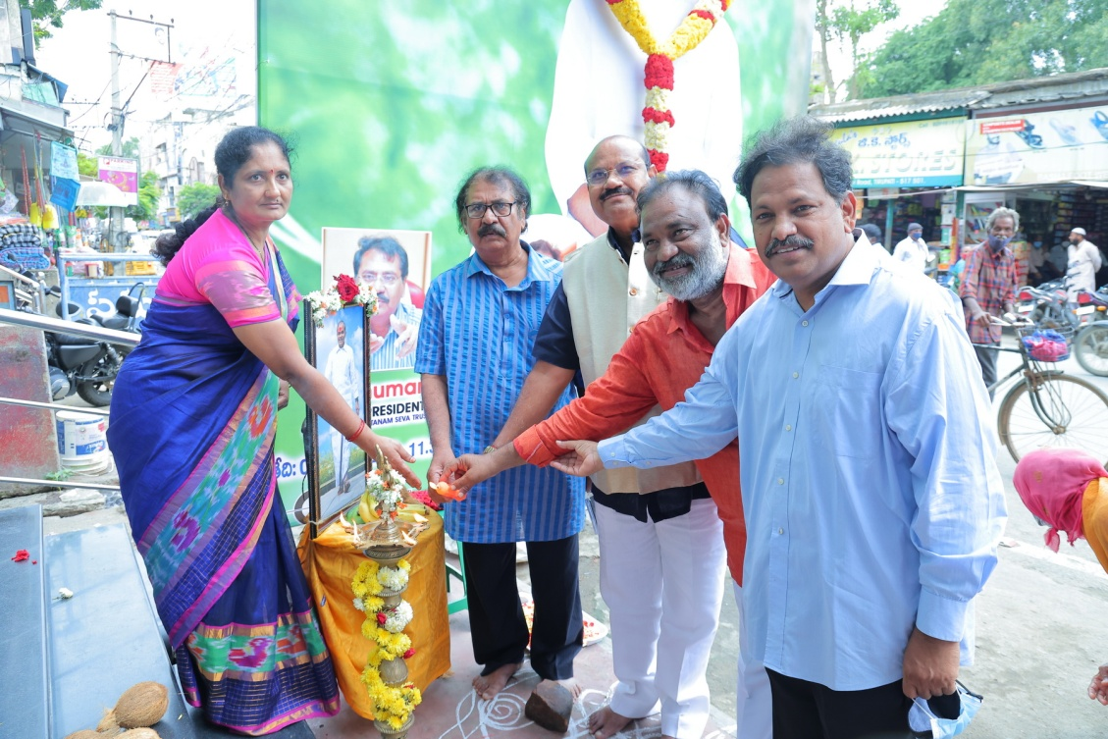
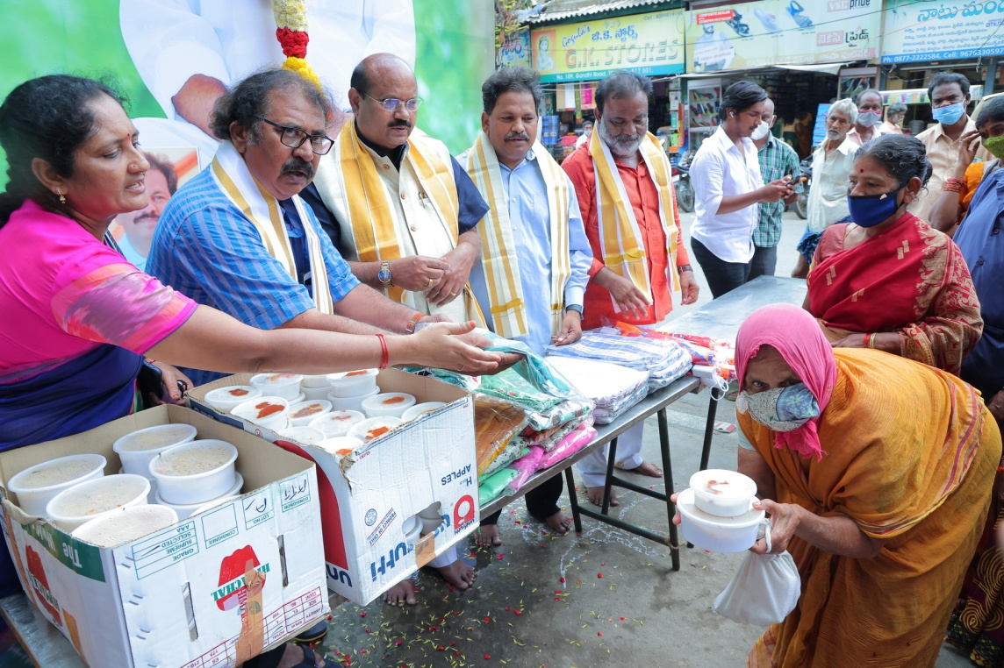
Dr YSR Prajaprasthanam seva trust on 02.09.2021 distributed cloths, food and umbrellas to 200.poor people at Gandhi road on occasion of his 12th death anniversary. Dr P.C. Rayulu, Chairman of the seva trust paid rich tributes to late YSR and lauded his programs during his tenure of Chief Minister provided free electricity for farmers, a health insurance program for rural people- Rajiv Aarogya Sree , 108 free ambulance services, full reimbursement of college tuition fee for underprivileged and reservations for Muslim minorities . Mr. Bhuman, Vice -President of seva trust said that apart of welfare schemes for underprivileged, his tenure also saw significant development in irrigation in united Andhra Pradesh. Mr. Palavali Ramachandra Reddy, Secretary of the trust said that programs during his stint were being cherished even today. Mrs. R. Sridevi ex officio member and Mr.S.K. Babu corporator of Tiupati municipal corporation were among those who participated. It is sixth program of seva trust after its formation distributing essential to the underprivileged people.

